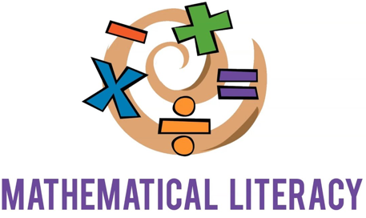

Overview of Mathematical Literacy:

Introduction:
Mathematical literacy is an individual's capacity to identify and understand the role that mathematics plays in the world. It allows individuals to make well-founded judgements and to use and engage with mathematics in ways that will foster independence. All students should have access to high quality, equitable, and engaging mathematics instruction (3).

Mathematical literacy is the ability of students to analyze, reason, and communicate ideas effectively as they formulate and solve mathematical problems in a variety of situations. Mathematical literacy includes numeracy (the ability to recognize numerals), number sense, and an understanding of mathematical concepts. Students with disabilities such as students who are Blind or visually impaired, or students who have a physical disability often do not have the same exposure to mathematical concepts as their peers. As a result, their mathematical skills may be lower than their age-level peers in school or they may never master mathematical concepts. It is critical that students with disabilities become mathematically literate so they can achieve their goals and be as independent as possible throughout their life (6).

Learning Objectives:
At the end of this module, the reader will gain an understanding of:
- The importance of math including basic mathematical concepts.
- How to develop skills of counting, matching, sorting, categorization, and discrimination
- What tools to be used with more complex mathematical concepts to students with disabilities

During this module you will be asked to reflect and write down your thoughts on how you will implement the content in this module. It is suggested that you have a way to write down your thoughts as you progress through this module.

GLOSSARY:
1:1 correspondence - is the skill of counting each object in a set once, and only once.

Accessible - is the practice of making information, activities, and/or environments sensible, meaningful, and usable for as many people as possible.

Alt Text: Alternative text, or “alt text” describes the content of images, graphs, and charts to someone who cannot perceive the image visually.

Executive Functioning: is a set of mental skills that include working memory, flexible thinking, and self-control.

Inclusion - the practice or policy of providing equal access to opportunities and resources for people who might otherwise be excluded or marginalized, such as those who have physical or mental disabilities, or members of other minority groups.

MathML: is a markup language designed to display equations (e.g. fractions, square roots, matrices, bounded integrals) on the internet and in other formats such as EPUB.

Screen Reader – A screen reader is an assistive technology, primarily used by people with vision impairments. It uses a Text-to-Speech engine to translate on-screen information such as text and button, into speech which can be heard through speakers or headphones. Some examples are JAWS, NVDA and Voice Over.

The importance of math:
Mathematical literacy is a vital skill not only in early education, but throughout life. It is critical to an individual’s independence. Mathematical knowledge also helps students understand other subjects in school such as social studies, science, and music Ernst 2005.
Additionally, students with and without disabilities will need mathematical literacy skills as they head into their future employment. Students with disabilities are less likely than their peers to obtain competitive employment. Since so many careers are related to STEM material (Science, Technology, Engineering and Math), it is crucial that students learn and master foundational mathematical concepts (1).

Basic Concepts:
An understanding of math begins with the development of basic concepts, such as attributes of size (big/small), weight (heavy/light), same/different and comparison (bigger/smaller and more/less), color and shape recognition. Recognizing and imitating patterns is another important early concept, whether the patterns be tactile, visual or both (e.g., rough, smooth or circle, square, triangle) (10). The following sections will give examples of how to teach these basic concepts to students with disabilities:

Functional Math Skills
The two main objectives of teaching math are to teach students critical thinking skills and problem-solving skills. Students with disabilities benefit from a lot of hands-on exploration of real objects from the natural environment. Exploration of various household items can help to develop basic concepts about size, shape, colour, and lay the foundation for classification skills, matching, and sorting. They can compare groups of objects and find the one that is "big" or "little" or "same". At the same time, experimenting with common objects provides lots of opportunities to practice counting and arranging items, and preparing for more advanced mathematical skills, such as addition and subtraction (4).

Counting and Number Sense:
Counting begins with rote counting, which can later be expanded to counting by 2s, 5s, 10s, 100s. An understanding of one-to-one correspondence is necessary to the ability to count items. Counting is a skill which requires the ability to count orally, as well as the ability to make smaller sets from larger sets (e.g., Given a student 5 spoons, then ask the student to give you 3)
Many objects can be used to support counting. It is better to use everyday objects, such as those from the student’s daily environment. Below is a video that demonstrates rote counting with large wooden beads.

The video below is of a student with a visual impairment using wooden beads to demonstrate number sense.

A media consent form was obtained for use of this video.

Place Value:
Place Value is one of the most important concepts when teaching math to students. It is the foundation of every math concept, such as learning operations of addition, subtraction, multiplication and division. It is how students learn to compare numbers; line up numbers vertically; make sense of addition, subtraction, multiplication, and division with larger numbers; and is the foundation for regrouping. Students have difficulty progressing in their mathematical literacy skills if they haven't mastered place value (14).

Use of a number line:
A number line is a line on which numbers are marked at intervals, used to illustrate simple numerical operations. In elementary mathematics, a number line is a picture of a graduated straight line that serves as visual representation of the real numbers. Every point of a number line is assumed to correspond to a real number, and every real number to a point.
There are many ways to create a simple number line either in vertical or horizontal form. For young children, it can be beneficial to use objects they are familiar with, or toys that are engaging (5). These objects can be formed into a number line, and labeled as such, illustrated in the examples below:
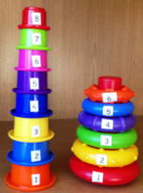
This is an example of a number line using stackable toys. The child can not only put them in size order, but in number order as well. This type of activity can teach children how to count in ascending and descending order.

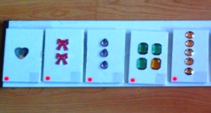This tactile number line is a way to help children count in ascending and descending order, as well as represent each number with various stickers.

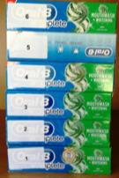This type of number line is meant to demonstrate that you can use boxes or any other readily available item in a number line.

Examples of how to develop Skills of Counting, Matching and Sorting:

Sorting:
Sorting helps children develop executive function skills, which are important cognitive skills that help with memory, attention and problem-solving. Research shows that the stronger these skills are when a child begins primary school the more likely they are to perform better at school overall (12).
There are several ways to teach the concept of sorting to young students with disabilities through visual, auditory, kinesthetic, and tactile methods. First, gather various objects and sort them based on different criteria. For example, gather various large and small objects and sort them by size or by what makes them similar or different. You can categorize 3D shapes and 2D shapes. Using objects of different textures and sounds will extend learning.

Utilize a concept hanger:
A concept hanger is a way to organize objects into categories. The concept hanger can be hung up vertically or placed on a table, such as in the picture below.
- Hang bracelets, metal objects, wooden objects, square/circular/rough/smooth/cold to touch objects.
- Change the objects each week, collect the objects with the child.
- Categorize the objects
- Sort by shape, size, length, texture, height
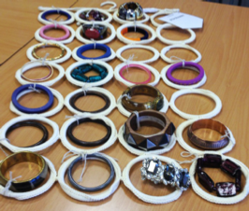

Utilize a concept bag:
A concept bag is a way place similar objects into categories. Place objects in a bag that all have the same quality or other similarities.
For example, if you are teaching a student the letter “R” you can put objects in the bag that begin with the letter “R” or use a word that starts with “R” such as “Roll”. You can put objects that roll into the concept bag such as a ball, rolling pin, or a paper towel roll.
You can also use a concept bag for objects that are the same thing but have different designs. For example, you can gather various headbands and ask the child to touch them to feel their different textures and designs, while reinforcing the concept that they are all headbands.
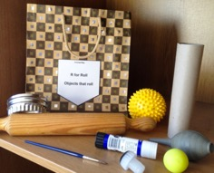
. 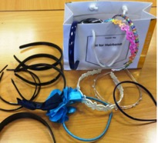

Understanding the qualities of an object:
You can gather similar objects to explore the different tactile qualities of each. For example, gather various wooden spoons and sort them by characteristics:
- Shortest to longest
- Handles of wooden spoon and different tops (fork)
- Categorize by spoon circumference - i.e., Thinnest to widest
- Measure using spoons

You can gather similar objects to explore how they each work. For example, gather various whisks and explore the qualities of each one:
- Whisk bubbles in a bowl with each whisk
- Make cupcakes using various whisks
- Make a mobile using whisks
- Explore electric hand whisk (while unplugged)
- Listen to the sound each whisk makes when it is used.
- Find out which is the heaviest or lightest whisk.

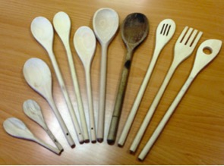
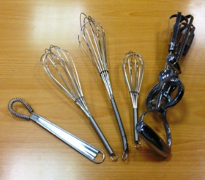

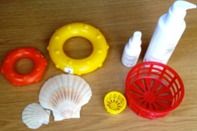
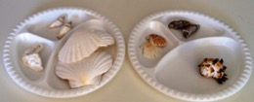

Gather various metal objects and explore the qualities of each. You can ask your students various questions such as: Is one heavier than the others? Is one type of metal more pliable than the others? The types of objects you can gather include:
- Oval metal tin
- Bracelets
- Clock
- Bolts
- Pastry cutter

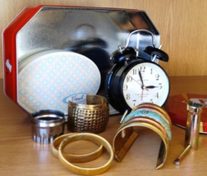

Activity:
Based on the information we have just discussed, take a moment and look around your room. What objects can use with your students to teach these basic mathematical concepts? Take a moment and write down two activities that you will try with your students in class this week.

Understanding Shapes: (9)
Although children accurately perceive shape and space in their everyday environments, preschool children ages three to five years benefit from learning to think about and understand concepts of basic geometry. Activities with shapes can also be used to teach sorting and categorization. For example, the teacher can create games and activities with various 2D and 3D shapes such as categorizing the shapes or matching the shape with the word. Examples below:
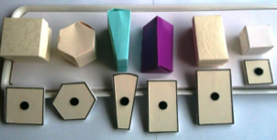 In this example activity, the 3D shapes can be attached to their corresponding 2D shapes. This activity can teach not only sorting and organization but also the concept of 2D and 3D objects.
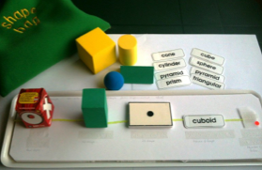In this activity, the word can be matched to the corresponding 3D shape. This activity combines teaching both math with literacy skills.

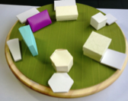In this activity, the 3D shapes of various sizes can be matched to their corresponding smaller or larger size to teach the concepts of small and large or smaller and bigger.

Making Patterns:
Patterns help children make predictions because they begin to understand what comes next. They also help children learn how to make logical connections and use reasoning skills. Patterns can be found everywhere in our daily lives and should be pointed out to small children, making it an important skill to teach (15). Examples of various activities with patterns are below:
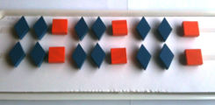 These tactile wooden blocks can be used to create various patterns. You can model an activity by creating one pattern and then ask your student to create one of their own.
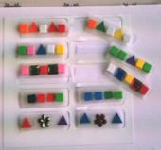These smaller blocks can be used to create various patterns. You can model an activity by creating one pattern and asking your student to replicate the pattern you created.

Additional tools for teaching more advanced mathematical skills:

Use of Peg board and Taylor Frame
Pegboard books provide a way for students who are Blind or visually impaired, as well as students with multiple disabilities, to demonstrate number sense and counting skills.
To use the Pegboard effectively, students with disabilities must have the following prerequisite skills:
- Fine motor skills
- Pincer grasp
- Concept of directions – i.e., top-bottom, right-left
- Number concepts such as counting

As children are picking up pegs and inserting them into the board, the teacher could reinforce their counting skills using the pegs. Once the students gain mastery by practicing at school and at home, the children can be introduced to the Taylor Frame.
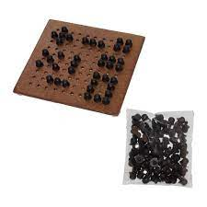

A Taylor frame is a device used for writing numbers and do mathematical operations. It consists of an aluminum frame, having a set of openings the shape of eight-pointed star. There are 18 columns and 25 rows. The pegs for writing are called types. The way the numbers are written, and calculations done are like the way the children write in their notebooks.
To use the Taylor frame effectively, students with disabilities must have the following prerequisite skills:
- Fine motor skills
- Pincer grasp
- Concept of directions – top-bottom, right-left
- Number concept - counting

Taylor Frames are either made of plastic or pieces of aluminum fitted into a wooden frame. The device consists of a set of metal pegs called types. There are 18 columns and 25 rows. One end of each peg or arithmetic types contains a solid raised bar, and the other end contains two dots. The side which has raised bar is used for writing numbers from 1 to 8, and the other side, which has two dots, are used for writing 9, 0 and signs for different operations, decimal and equal to (=). The positions are shown in the figure. The first row shows numbers from 1 to 8, and the second row shows numbers 9, 0, plus sign (+), minus sign (-), Multiplication sign (*), Divide sign (/), decimal sign (.) and equal to (=).
Different kinds of types are available for writing variables in algebra in higher level classes.
Initially students can insert the types in random position, and the position for writing numerals can be introduced as they gain mastery.
The pegs are slightly embossed, which helps in identification of the orientation by students who are Blind or visually impaired. The meaning of different orientations of pegs are described below:
- Raised bar side for writing numbers from 1 to 8
- Two dots side for writing numbers 9 and 0, and for writing symbols of mathematical operations and decimal
- Algebra types for writing variables, various kinds of brackets

Below is an image of the Taylor frame. The video below demonstrates how to utilize a Taylor frame. Additional information can be found in Annexure A:

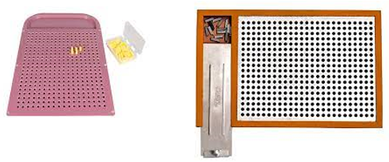

Abacus:
An abacus is a calculating device in which beads are moved to make arithmetic calculations. An Abacus is one of the best ways to improve arithmetic skills and number fluency. Abacus facilitates speedy calculations and can be used as a tool to also teach mathematical concepts to early learners (Furner.). Examples of an abacus are listed below:

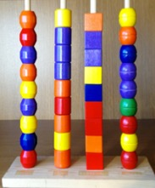You can use an abacus to teach rote counting to young children. You can also explore the concepts of addition and subtraction. Using an abacus can also be a way for a child to demonstrate to you that they understand the concepts of addition and subtraction.
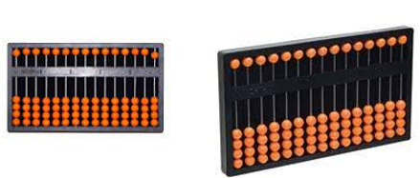Both of these suanpan abacuses can be used for equations and problems with higher numbers. The beads on the top represent the number 5, while the beads on the bottom represent the number 1. Also, each column is assigned a place value. Additional information on this type of abacus is detailed below in Annexure A.
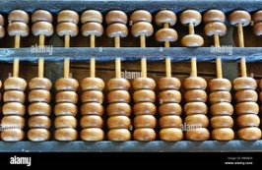

Geoboard And Geometry Kit for Tactile Shapes: (Russell, 2020)
Geoboards are square boards that have pegs to which students attach rubber bands to form various shapes. Geoboards come in 5-by-5 pin arrays and 10-by-10 pin arrays. The geoboard is just one of many math manipulatives that can be used in math to support understanding of a concept. Math manipulatives help teach concepts in a concrete method to students with disabilities, before teaching them the same concept in symbolic format. Geoboards are used to support early geometric, measurement, and numeracy concepts.
Students with disabilities can be shown tactile geometrical shapes using the sharp material used for drawing in sheets, where the reverse side of the diagram made will be tactile. Then students can be taught to use the geoboard and geometry kit and make diagrams. Examples of these tools are below:
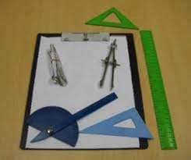
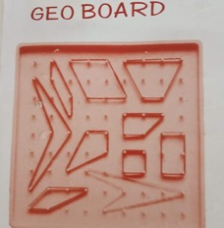
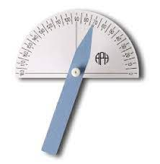

Activity:
In thinking about what we have learned so far in this module, how would you incorporate these activities with the students in your classroom? Write down one or two ideas about what activities you can try in your classroom this week.

Computerized Tools and Techniques for making advanced math accessible to students with disabilities:
With the advancement of computer technology, software programs have been developed that make math and scientific content accessible to students who are visually impaired and use screen readers. In this section we will be discussing MathType, which is a free software program that works with MS Word and is for students in upper primary school who may be doing more advanced math:

MathType
MathType is an interactive accessible equation editor. It provides accessible ways of writing mathematical equations in Microsoft Word documents and other types of documents. It can be used on Window PCs, or Macs.
Math ML is a mathematical markup language designed to display equations, (e.g. fractions, square roots, matrices, bounded integrals) on the web and in other formats such as EPUB.

Process
There are two ways of writing mathematical equations using MathType: with MathType editor and without editor. MathType editor is completely accessible with NVDA, a screen reader used by students with visual impairments. It provides features to write mathematical equations with the help of keyboard by using shortcut keys.
A 30-day trial is available free of cost which can be downloaded from:
http://www.dessci.com/en/products/MathType/trial.asp

Conclusion:
From this module, we have learned:
- The importance of math including basic mathematical concepts.
- How to develop skills of counting, matching, sorting, categorization, and discrimination
- Tools that can be used with more complex mathematical concepts for students with disabilities

Mathematical literacy is vital to an individual’s capacity to make well-founded judgements. It is also crucial to use mathematics in ways that help the individual become a constructive, concerned, and reflective citizen. Students with disabilities can learn mathematical concepts through the use of various tools and strategies. Learning and understanding math will allow students with disabilities to achieve their goals and live a productive life.

References:
- Arthur, C., Badertscher, E., Goldenberg, P., Moeller, B., McLeod, M., Nikula, J., & Reed, K. (2017). Strategies to improve all students’ mathematics learning and achievement. Waltham, MA: EDC.

- Brawand, A.C., & Johnson, N.M. (2016). Effective Methods for Delivering Mathematics Instruction to Students with Visual Impairments. Journal of Blindness Innovation and Research, 6(1). Retrieved from https://nfb.org/images/nfb/publications/jbir/jbir16/jbir060101.html. doi: http://dx.doi.org/10.5241/6-86

- Basham, J., & Marino, M. (2013). Understanding STEM education and supporting students through universal design for learning. Teaching Exceptional Children, 45(4), 8–15.

- Clements, D. H. Geometric and spatial thinking in young children. In Copley, J. V. (Ed.). (1999). Mathematics in the early years. Reston, VA: National Council of Teachers of Mathematics.
- Douglas H. Clements, PhD. and Julie Sarama, PhD. Math Play: How young children approach math. Scholastic Early Childhood Today, Jan/Feb 2005

- Early Childhood Mathematics: Promoting Good beginnings National Association for the Education of Young Children (NAEYC) and the National Council of Teachers of Mathematics (NCTM). Adopted in 2002. Updated in 2010.

- Ernest, P. (2005). Platform: Why teach mathematics? Mathematics in School, 34(1), 28–29.
- Furner, J. M., Yahya, N., & Duffy, M. L. (2005). Teach Mathematics: Strategies to Reach All Students. Intervention in School and Clinic, 41(1), 16–23. https://doi.org/10.1177/10534512050410010501

- Ginsburg, H.P. & Oppenzato, C. What Children Know and Need to Learn about Shape and Space. Retrieved from https://prek-math-te.stanford.edu/spatial-relations/what-children-know-and-need-learn-about-shape-and-space on December 7, 2022

- Klingenberg, O. G. (2012). Conceptual Understanding of Shape and Space by Braille-Reading Norwegian Students in Elementary School. Journal of Visual Impairment & Blindness, 106(8), 453-465. https://doi.org/10.1177/0145482X1210600802

- Na, K.S., Lee, S.I., Park, J.H., Jung, H.Y., Ryu, J.H. Association between Abacus Training and Improvement in Response Inhibition: A Case-control Study. Clinical Psychopharmacology Neuroscience. 2015 Aug 31;13(2):163-7. doi: 10.9758/cpn.2015.13.2.163. PMID: 26243843; PMCID: PMC4540045.

- Platz, D. L. (2004). Challenging young children through simple sorting and classifying: A developmental approach. Education, 125(1).

- Russell, Deb. (2020, August 27). Using a Geoboard in Math. Retrieved from https://www.thoughtco.com/using-a-geo-board-in-math-2312391 on December 7, 2022

- Sherman, H.J., Richardson, L.I. & Yard, G.J. (2014). The impact of place value on mathematics. Retrieved from http://www.education.com/reference/artcile/impact-place-value-mathematics/ on December 7, 2022

- Wijns,N., DeSmedt,B., Verschaffel, L., & Torbeyns, J. (2019). Are preschoolers who spontaneously create patterns better in Mathematics? British Journal of Educational Psychology, 90(3), 753-769. https://doi.org/10.1111/bjep.12329

Annexure A:

Additional Information for using a suanpan abacus:
This website will provide additional information on how to use an abacus: https://study.com/learn/lesson/abacus-overview-examples-uses.html
The video below explains how to use a suanpan abacus for calculations. The original link can be found here: https://www.youtube.com/embed/FTVXUG_PngE?feature=oembed

Additional Information about the Taylor Frame:
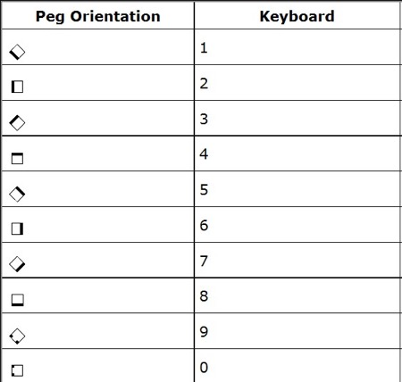

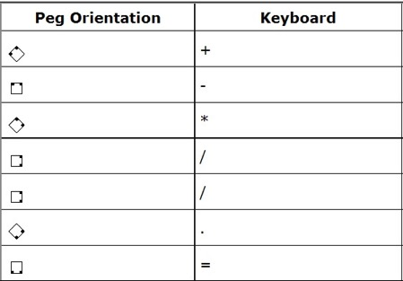

Once a student with a disability learns to write mathematical equations on a Taylor frame, they can learn to write any work being done in arithmetic, and in later years, algebra.
Now, here is an example where we do a division operation in sighted convention and then in the Taylor frame convention.
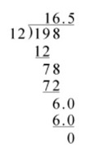
Sighted convention of a long division problem
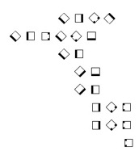
Taylor frame conversion of the same problem

Limitations of the Taylor frame to keep in mind:
- The Taylor frame has only 18 rows and 25 columns, which limits the calculation length. Hence, one cannot do long calculations
- Slow and tedious job
- The solution cannot be stored for future reference, as the types must be removed after the problem is solved.
Additional resources for utilizing a Taylor Frame can be found at: https://www.pathstoliteracy.org/6-tips-teaching-maths-students-visual-impairments/

Additional Computerized Tools and Techniques for making advanced math accessible to students with disabilities:

Design Science Products
Design Science Inc. (DSI) is a United States based company working since 1986 for the development of software for scientific and technical communication. Design Science has developed MathPlayer for accessing scientific content accessible with the screen reader NVDA (Non-Visual Desktop Access) by the partially sighted / visually impaired.

MathPlayer
Design Science has developed a tool to give speech output for scientific content in Microsoft Word, PowerPoint, Internet Explorer, and Firefox. This tool is named as MathPlayer. It works only with the screen reader NVDA.
Design Science MathPlayer is free of cost which can be downloaded from:
http://www.dessci.com/en/products/mathplayer/download.htm?utmmedium=VCheck&utmsource=MPW&utmcampaign=MPW4

Limitations of Design Science Products
Design Science has made scientific content accessible to partially sighted/visually impaired at a reasonable cost but still it has some limitations. Some of which are:
- Supports content written with the help of MathType only.
- No tool to support text on graphics, i.e., no feature to read printed books by scanning.

